**Programming 1 (PRG1)**

Year 1 (2025/26), Semester 1

**SCHOOL OF INFOCOMM TECHNOLOGY**

Diploma in Cyber Security & Forensics

Diploma in Data Science

Diploma in Immersive Media

Diploma in Information Technology

Common ICT Programme

# Mini Tasks #1

**Due on 14 May 2025 (Wednesday), 2359 hours**

**Weightage:**  5% of Module

**Individual/Team/Both:** Individual

**Penalty for late submission:**

* + 10% per day from the due date.
  + NO submission shall be entertained after 7 calendar days of the due date.

There is a total of 5 pages (including this page) in this handout.

|  |
| --- |
| ***WARNING***  ***If a student is found to have submitted work not done by him/her, he/she will not be awarded any marks for this assignment. Disciplinary action will also be taken.***  ***Similar action will be taken for the student who allows other student(s) to copy his/her work.*** |

**1. OBJECTIVE**

This is one of the mini-task in the series to assesses the student’s ability to apply relevant programming concepts to develop simple application using Python programming language in Weeks 1 to 3.

**2. SCOPE**

The mini-task shall be one out of four mini-tasks given to allow students to demonstrate their understanding of concepts taught in the weeks.

For this mini-task01, you are expected to:

* Understand the problem completely and plan your program layout before you start coding
* Develop the solution for each task based on the requirements or screenshots given.
* Your solution should be within the scope of the material taught.

**A. Gamer’s Final Score**

The final performance score in a tournament for any gamer is calculated based on 30% of kill count, 30% of the objective completion and 40% of survival time.

1. State the input, processing and output needed to solve the problem.

1. Develop a pseudocode to calculate and display the final performance score.

* You may assign kill count as 50, objective completion as 80 and survival time as 90.

1. Write a simple python program (GameScoreCalculator.py) to solve this problem based on the pseudocode developed.

**B. Movie Budgeting**

Suppose you are planning for a movie night with friends and you wish to calculate the total cost for snacks, drinks and tickets. The cost of each snack is $2.50 and drinks are at $1.80 each. Tickets for the movie cost $12 each. There is a 10% service fee added to the total cost of the snacks, drinks and tickets.

Write a Python program to do the following

* Prompt the user to enter the number of movie tickets they want.
* Prompt the user to enter the number of snacks they want to buy.
* Prompt the user to enter the number of drinks they want to buy.
* Calculate the total cost of the purchase, before adding the service fee and display the total cost before service fee.
* Calculate the total cost of the purchase with the service fee included and display the total cost as the grand total.

The following are some samples of the program.

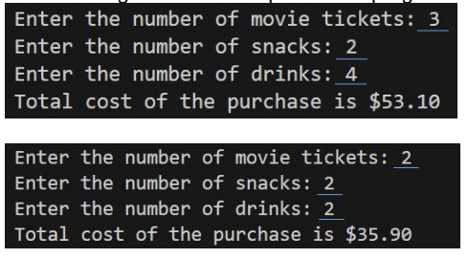

**C. Hocus Pycus**

We are wizards studying in the School of Python Magic. A spellbook would need to be created. The spellbook shall have the following abilities.

* Store the following spells
  + Rain of Fire
  + Ice Lance
  + Teleport
  + Mana Ward
  + Arcane Missiles
* Display the list of available spells to the user
* Prompt the user to pick the sequence of activating the spells 5 times.
* Display the sequence chosen by the user and create an ultimate secret spell by combining the first, third and last spell together.

The following are some samples of the program

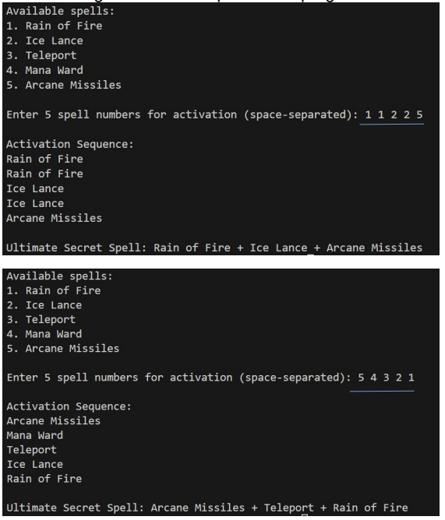

**Note:** You are only allowed to use the concepts taught up to Week 3.

**Note:**

* ***You are expected to follow naming conventions introduced in this module.***
* ***You are encouraged to implement all the questions based on the material taught.***
* ***You should think carefully what input is required for each option if there is any.***
* ***Marks will be deducted if you are not able to show your understanding of the program.***

**6. DELIVERABLES**

* Create a folder, **MiniTask01**, on your hard disk.
* Save this word document as **MiniTask1-YourName.docx** in the **MiniTask01** folder created above.
* For each question, type your answer into the box provided in the question.
* For the questions that require you to write Python program, create the Python program with the given file name in the **MiniTask01** folder created above. Do add the description, your name and student ID as comments at the beginning of each program.
* At the end of the session, save this word document, compress all the files in your **MiniTask01** folder (i.e. the Python program files and this word document) and submit the zip file in POLITEMall.